BAHRIA UNIVERSITY KARACHI CAMPUS
Department of Computer Science

APPLIED PHYSICS

LAB EXPERIMENT # 8

RLC Rejecter circuit

OBJECTIVE:-

- To study the characteristics of Rejecter (Parallel RLC) circuit and to determine the value of unknown Inductance.

EQUIPMENT:-

- Parallel RLC Circuit Trainer.
- Function Generator.
- Micro Ammeter.

THEORY:-

Rejecter circuit is a parallel RLC circuit. It is called rejecter circuit because it rejects maximum current at certain frequency called the resonant frequency or in other words it offers maximum impedance at resonant frequency.

R Ω
L M h
AC signal
C μ F
μ A

The equivalent impedance of parallel RLC circuit can be written as the sum of individual impedances of R, C & L.
i.e.
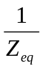= 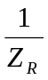 + 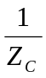 + 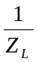- - - - - - - - - - - - - - - (i)

On left hand side of eq(1), we have reciprocal of impedance which is called as admittance denoted by Y; having unit called Siemens, hence:
Y_{eq} =

And Z_{R} = R, Z_{C} =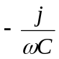, Z_{L} = jωL
Eq (i) becomes:
Y_{eq} = + 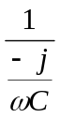+ 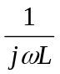- - - - - - - - - - - - - - - (ii)
The reciprocal of resistance is called as conductance whose SI unit is Siemens (also called mho). The conductance is denoted by G
i.e.
G =
Simplifying eq (ii), we have

Y_{eq} = G - 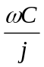+
Y_{eq} = G – (-j)ωC+ 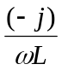
Y_{eq} = G + jωC -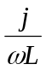
Y_{eq} = G + j(ωC – 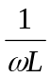)- - - - - - - - - - - - - - - (iii)
Under resonance, the imaginary term of impedance is zero i.e.

ωC –= 0
Simplifying;
or ω²C = 

or ω² = 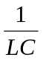
or ω = 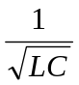

or ω_{r} = (ω_{r} denotes resonant frequency)
where ω = 2πf
where,
C = Value of capacitance (μF),
f_{r} = Resonant Frequency (Hz),
L = Inductance (H)

therefore;
f_{r} = 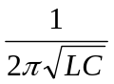

This is the frequency at which the admittance of a parallel circuit is purely real and is called as resonant frequency.
Since impedance is the reciprocal of admittance, therefore at resonant frequency impedance will be maximum when admittance is minimum and current will be minimum i.e.
|Z| = 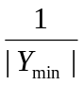
|Y| mho
f_{r}
| Z |
| Y |
| Z | (ohm)
G
(G = 1/R)
f (Hz)

PROCEDURE:-

- Set the amplitude of the input at such a level that ammeter starts to detect the current in the parallel circuit.
- Apply sinusoidal voltage at the input of rejecter circuit with frequency
01 kHz.
- Proceed the experiment by increasing frequency in steps of 100 Hz.
- Record the frequencies and respective current values.
- Plot the graph between frequency and current & log of frequency and current.

| Z | (ohm)
I (μA)
f_{r}
f (Hz)
| Z |
I (μA)
- Locate the frequency on the graph where current is minimum, this is the resonant frequency f_{r}.
- With the help of resonance frequency, find the value of inductance L of inductor using the following formula.

L = 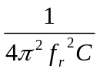

2πf = or 4π²f _{r}² = 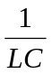 or

OBSERVATIONS:- (C= 0.01 μF)

S. No | Frequency ’f’ (Hz) | Current I (μA) | log f
1
2
3
4
5
6
7
8
9
10
11
12
13
14
15
16
17
18
19
20

RESULTS:- (C= 0.01 μF)

1. Observed resonant frequency = __________________

2. The calculated value of inductor = _______________

Note: Show all performed calculations.

Teacher Signature: ________________________

Student Registration No: ________________________

